- Client stores sales data for each month in separate excel files in a common folder. The requirement is to load the data only from latest file in that folder every time data refresh is done.

- The client adds a new first sheet to store the sales for latest month. The requirement is to load the data only from the first sheet in the file whenever data refresh is done.
- Set the Friday as the week start day for the clients in UAE
- Find the difference between the play time of current game and previous game
Input:
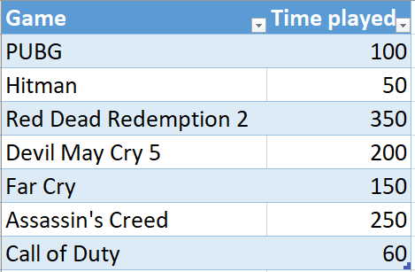
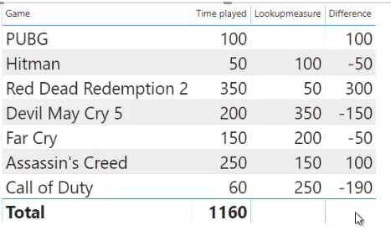
Output:

- Load Store, books and sales table from Pubs. Create slicers with title and book type. Create a table that shows all books. When you select a title, only that book is displayed in the table by default. However, the requirement is to display all the books under book type of currently selected book. (Hint: Use Chiclet Slicer) Same as Qn. 7

- Find how many customer complaints are still open on each date
- Show and hide measures dynamically in a visual based on the user’s selection
- Load Store, books and sales table from Pubs. Create 3 measures – Total Qty, Total Royalty and Total Sales. In a table visual, show only the measures selected by user.

- Display Multiple dynamic measures with proper field names in above solution

- Load Store, books and sales table from Pubs.xlsx. Create a measure to find sales amount. Allow users to view top N and bottom N books based on sales amount. Use column chart visual.

